**S1 Fig. Accuracy, loss, and testing results on validation folds.**

Training and testing results for 10-fold validation: accuracy and loss for each fold during the training process (A). The precision and recall for each fold (B).

**A**

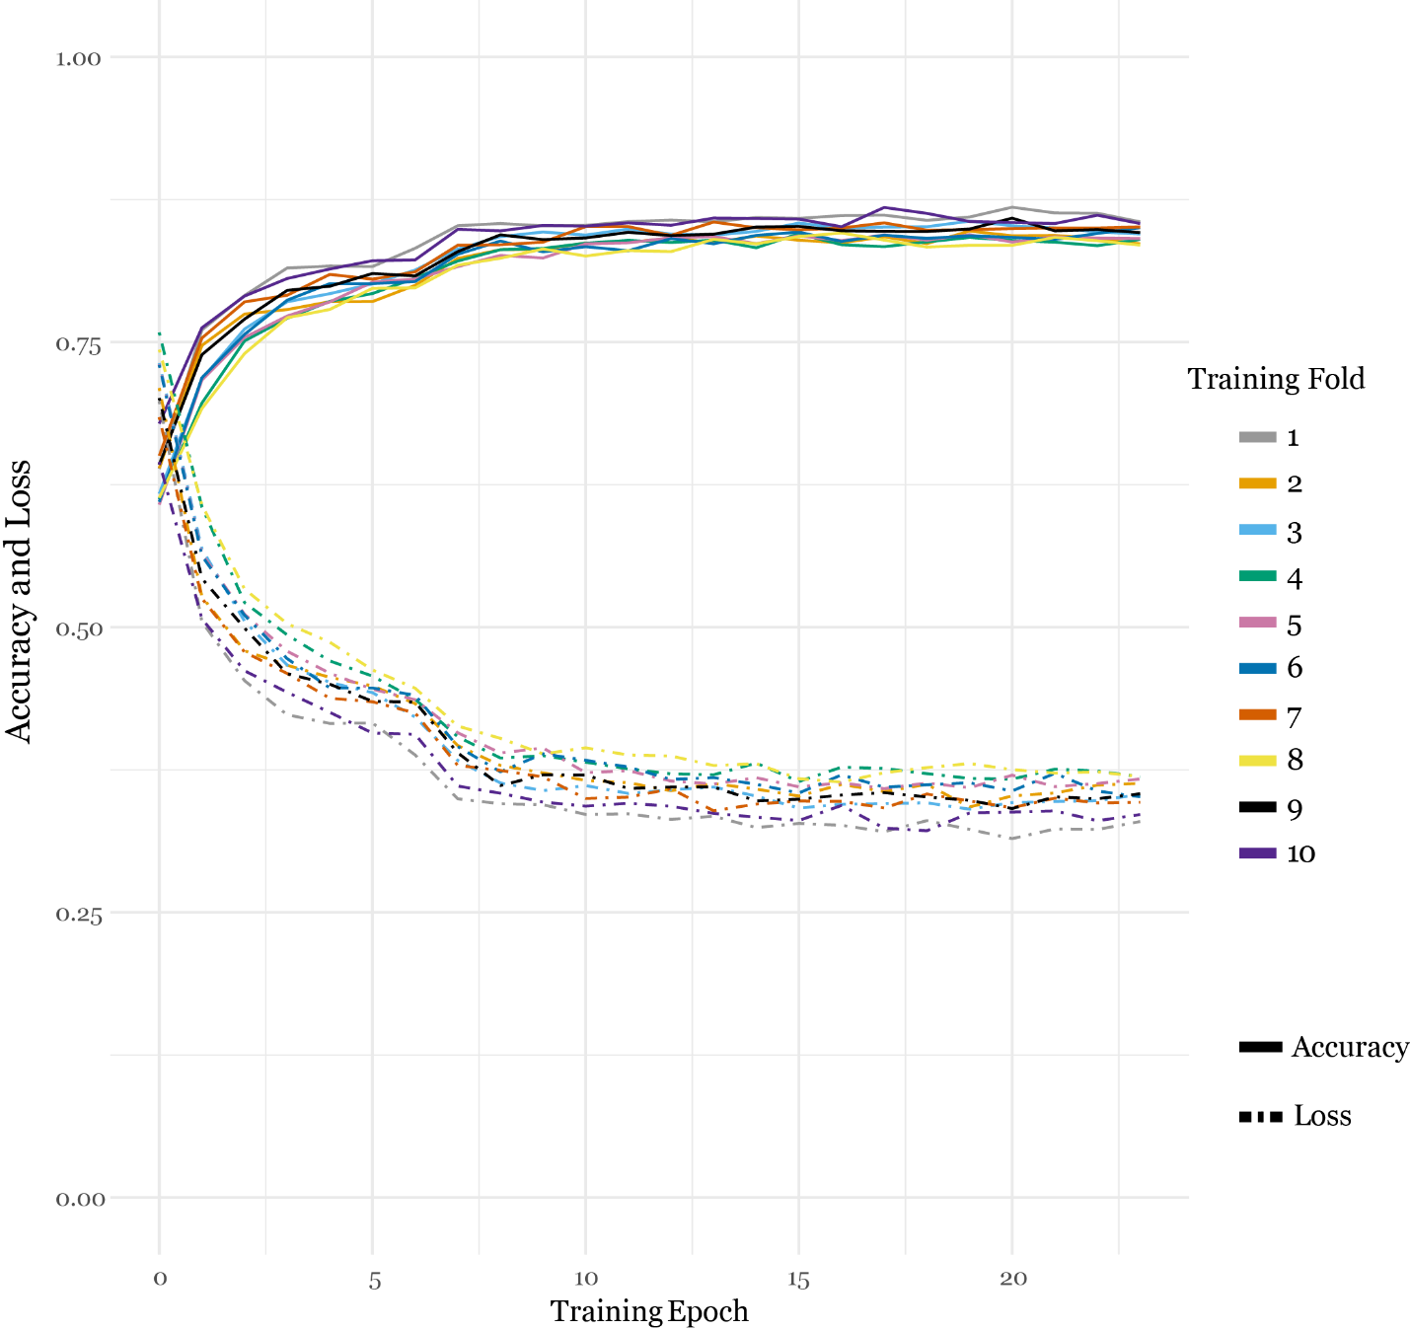

**B**

